Customer Churn Prediction System
A Scientific Reproducibility Study Based on a Machine Learning Approach

Methodology : CRISP-DM

Prepared by: Yorna Salouej
Rayen Samaali
Yassin Raihi

Academic Year
2025 – 2026

Table of Contents
General Introduction 7
Chapter 1: General context of the project 8
1. Introduction*** 8
1.1 Customer Churn in the Telecom Industry 8
1.2 Problem Statement 9
1.3 Objectives of the Study 9
1.4 Scientific Reproducibility Perspective 10
1.5 Report Organization 10
Chapter 2: Business Understanding 12
2. Business Understanding (CRISP-DM – Phase 1) 13
2.1 Business Objectives 13
2.2 Data Mining Objectives 13
2.3 Success Criteria 15
Chapter 3: Data Understanding 16
3. Data Understanding (CRISP-DM – Phase 2) 16
3.1 Dataset Description 16
3.2 Feature Description 18
3.3 Initial Data Exploration 19
3.4 Exploratory Data Analysis (EDA) 20
3.5 Insights from Data Understanding 20
Chapter 4: Data Preparation 22
4. Data Preparation (CRISP-DM – Phase 3) 22
4.1 Data Cleaning 22
4.2 Data Transformation 23
4.3 Feature Selection Strategy 23
4.4 Handling Class Imbalance 24
4.5 Final Prepared Dataset 24
Chapter 5: Modeling 26
5. Modeling (CRISP-DM – Phase 4) 26
5.1 Reproduced Machine Learning Models 26
5.2 Ensemble and Boosting Techniques 26
5.3 Experimental Setup 27
5.4 Cross-Validation k = 5 : ? 27
Chapter 6: Evaluation 29
6. Evaluation (CRISP-DM – Phase 5) 29
6.1 Evaluation Metrics 29
6.2 AUC and ROC Curve Analysis 29
6.3 Reproduced Results 29
6.4 Discussion on Results 30

List of Figures

List of Tables

List of Acronyms

GSA
AUC

General Introduction

Chapter 1: General context of the project

Introduction***
Customer churn is a major challenge in the telecom industry due to fierce competition and frequent customer movement. Predicting churn helps companies take proactive steps and make better decisions using analytics and machine learning.
This project reproduces a scientific article on churn prediction to test its reliability and expands the analysis with clustering, explainable AI, and performance improvements.

Customer Churn in the Telecom Industry
Customer churn refers to the phenomenon where customers discontinue their subscription or switch from one service provider to another. In the telecommunications industry, churn has become a major concern due to the rapid growth of competition and the increasing number of service providers in the market. As highlighted in the reference article, customer retention is significantly less costly than acquiring new customers, making churn management a strategic priority for telecom companies.
The business impact of customer churn is substantial, as it directly affects revenue, market share, and long-term profitability. Customer dissatisfaction, particularly related to service quality and customer support, is identified as one of the primary drivers of churn. Consequently, the ability to accurately identify customers who are at risk of leaving allows companies to design effective retention strategies and improve customer loyalty. With the availability of large volumes of customer data, data-driven approaches have become essential for understanding customer behavior and predicting churn patterns.

Problem Statement
Customer churn prediction is formulated as a binary classification problem, where customers are categorized as either churners or non-churners. The main challenge lies in accurately modeling customer behavior using historical data in order to detect early signals of churn. Traditional churn management approaches can be classified into two categories: reactive and proactive.
In a reactive approach, companies wait until a customer submits a cancellation request before taking action, often by offering incentives or promotional plans to retain the customer. In contrast, a proactive approach aims to predict the likelihood of churn in advance and take preventive measures accordingly. As emphasized in the article, proactive churn prediction is more effective, as it enables companies to intervene before customers decide to leave. Machine learning techniques have proven to be particularly suitable for this task due to their ability to learn complex patterns from historical data and provide accurate predictive insights.

Objectives of the Study
This figure summarizes the main objectives of the study, highlighting the scientific reproducibility analysis, the replication of the experimental pipeline, and the proposed methodological improvements, including customer segmentation and the integration of explainable AI techniques.

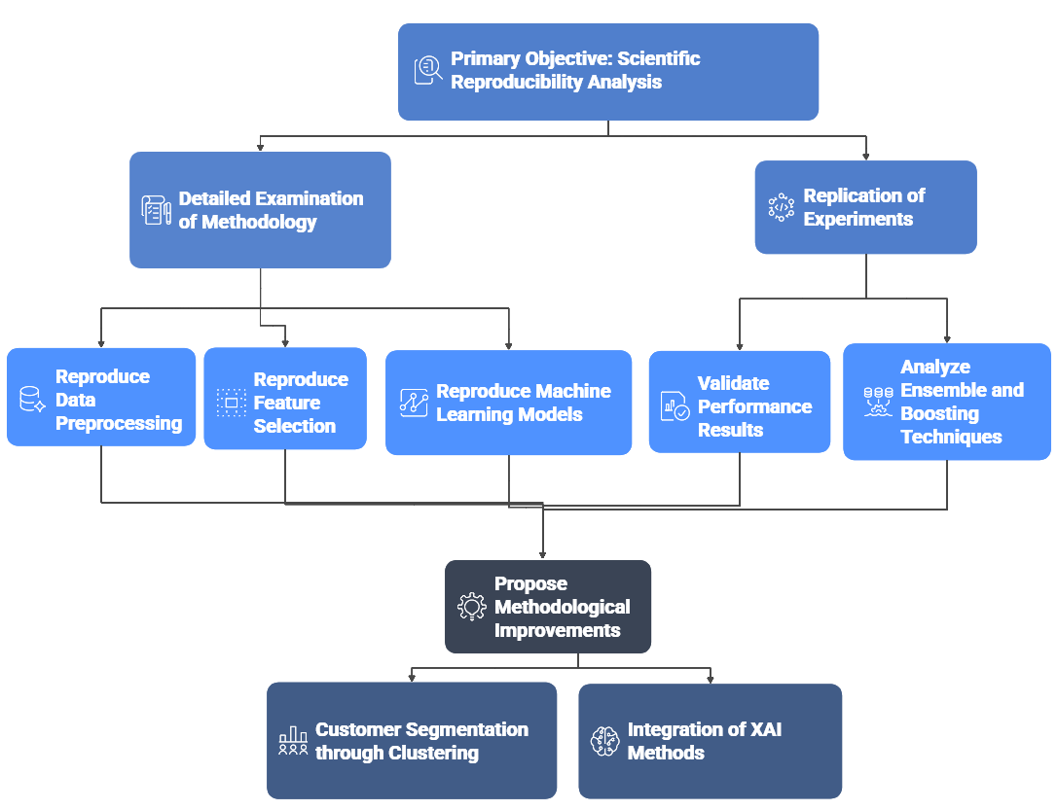
Overview of the Study Objectives and Reproducibility Framework

Scientific Reproducibility Perspective
Scientific reproducibility is a fundamental principle in data science and machine learning research. It ensures that published results can be independently verified and that conclusions are reliable and transparent. In the context of customer churn prediction, reproducibility is particularly important, as business decisions based on predictive models must be trustworthy and robust.
This study focuses on reproducing the complete experimental pipeline described in the reference article, including data understanding, preprocessing, feature selection using the Gravitational Search Algorithm (GSA), model training, and evaluation. The scope of reproduction covers the dataset structure, machine learning algorithms, experimental setup, and performance metrics such as accuracy, precision, recall, F-measure, and AUC. Any deviations between the reproduced results and the original findings are carefully analyzed and discussed.

Report Organization
This figure illustrates the overall organization of the report, outlining the progression of chapters aligned with the CRISP-DM methodology, from business understanding to deployment considerations and future work.

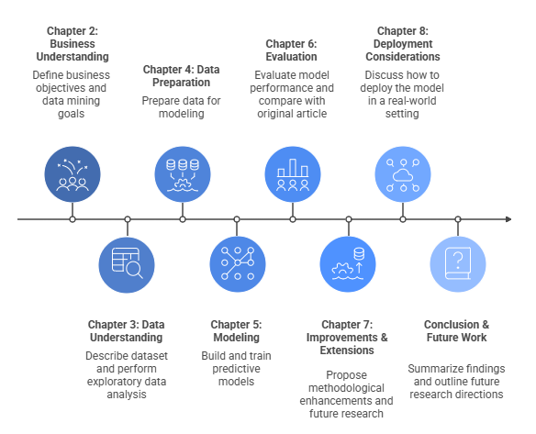
Structure and Organization of the Report Based on the CRISP-DM Methodology

This section presented the context, objectives, and scope of the project, highlighting the importance of churn prediction and reproducibility in data-driven research. It clarified the dual contribution of the work: validating the original study and proposing meaningful extensions. The remainder of the report builds on this foundation by detailing the methodology, results, and enhancements introduced in the study.
Ajouter des citations IEEE / Springer

Chapter 2: Business Understanding

The Business Understanding phase of the CRISP-DM methodology focuses on defining the business problem and translating it into clear data mining objectives. In this project, the main challenge is customer churn, which represents a major threat to business profitability. Predicting churn allows organizations to identify customers at risk of leaving and to implement effective retention strategies. This chapter outlines the business objectives, data mining goals, and success criteria guiding the churn prediction project.

Business Understanding (CRISP-DM – Phase 1)

Business Objectives
In the highly competitive telecommunications industry, customer retention has become a critical strategic objective for service providers. As emphasized in the reference article, retaining existing customers is significantly less costly than acquiring new ones, and even a small reduction in churn rate can lead to substantial financial benefits. Customer churn directly impacts revenue, profitability, and market share, making it a key concern for telecom operators operating in saturated markets.
The primary business objective of this study is to support churn reduction by enabling the early identification of customers who are at risk of leaving the service provider. By predicting churn behavior in advance, companies can design targeted retention strategies, such as personalized offers or improved customer support, rather than relying on reactive approaches that are often less effective. Therefore, a reliable churn prediction system serves as a valuable decision-support tool, allowing businesses to optimize customer relationship management and enhance long-term customer loyalty.
Summarize picture
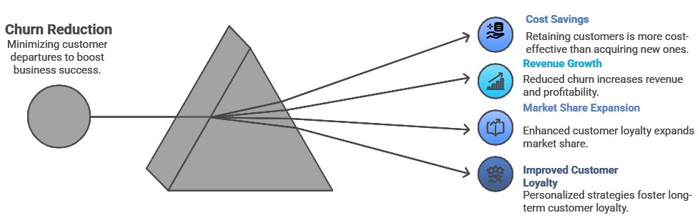
Business Objectives***

Data Mining Objectives
The primary objective of this data mining project is to predict customer churn, defined as whether a customer is likely to discontinue using a company’s services (Yes / No). Customer churn prediction is a critical task in customer relationship management, as retaining existing customers is often more cost-effective than acquiring new ones. By leveraging historical customer data and machine learning techniques, the organization can proactively identify high-risk customers and take targeted retention actions.
To achieve this objective, the project aims to build and evaluate multiple machine learning models capable of performing binary classification. These models are trained using relevant customer attributes such as demographic information, service usage patterns, billing details, and interaction history. Comparing multiple algorithms allows us to identify the most effective model in terms of predictive performance, robustness, and interpretability. This comparative approach ensures that the final selected model is not only accurate but also suitable for real-world deployment.
Summarize
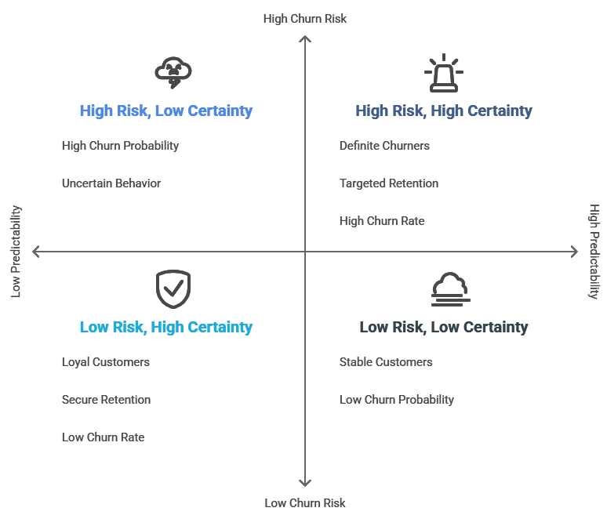
********

Success Criteria
The success of the churn prediction system is evaluated using both business-oriented and technical criteria. From a business perspective, the system is considered successful if it can accurately identify customers who are likely to churn, thereby enabling proactive retention actions and supporting strategic decision-making. The model should provide insights that are actionable and useful for improving customer retention policies.
From a technical standpoint, the success criteria are defined using standard classification performance metrics, as adopted in the reference article. These metrics include accuracy, which measures the overall correctness of the model; recall, which evaluates the ability to correctly identify churners; precision, which assesses the reliability of churn predictions; and the F-measure, which provides a balance between precision and recall. In addition, the Area Under the ROC Curve (AUC) is used as a global performance indicator to evaluate the model’s ability to discriminate between churners and non-churners across different classification thresholds. Together, these metrics provide a comprehensive framework for assessing the effectiveness and robustness of the churn prediction models.

Dimension | Criterion | Description | Importance
Business | Churner Identification | Ability of the system to accurately identify customers likely to churn | High
Business | Decision Support | Provision of actionable insights for business teams | High
Business | Actionability | Usefulness of results in triggering targeted retention actions | Medium to High
Technical | Accuracy | Overall proportion of correct predictions | Medium
Technical | Recall | Ability to correctly detect churners | Very High
Technical | Precision | Reliability of churn predictions | High
Technical | F-measure (F1) | Balance between precision and recall | High
Technical | AUC | Overall capability to discriminate between churners and non-churners | Very High
Success Criteria for the Churn Prediction System

This phase has clearly defined the business and analytical objectives of the project. The goal is to predict customer churn as a binary outcome (Yes/No) using machine learning models and to compare their performance. Clear success criteria, both business-oriented and technical (Accuracy, Precision, Recall, F-Measure, AUC), have been established. These definitions provide a solid foundation for the next CRISP-DM phases and ensure alignment between business needs and data-driven solutions.

Chapter 3: Data Understanding

The data understanding phase aims to explore the dataset and assess its suitability for the customer churn prediction task. This phase focuses on examining the structure of the telecommunications churn dataset, identifying feature types, analyzing the target variable distribution, and detecting potential data quality issues such as missing values and class imbalance. In addition, exploratory data analysis (EDA) is performed to identify key relationships between customer attributes and churn behavior, providing guidance for subsequent data preparation and modeling phases.

Data Understanding (CRISP-DM – Phase 2)

Dataset Description
The dataset used in this study is a telecommunications customer churn dataset, as described in the reference article. It contains historical information about customers, including demographic details, subscribed services, billing information, and churn status. The dataset is designed to support the analysis and prediction of customer churn behavior in the telecom industry.
The dataset consists of approximately 7043 customer records with 21 attributes. These attributes represent a combination of categorical and numerical features that capture different aspects of customer behavior and service usage. The richness of the dataset allows for a comprehensive analysis of factors that may influence customer churn.
The target variable of the dataset is Churn, which indicates whether a customer has discontinued the service or not. This variable is categorical and binary in nature, taking two possible values: Yes (customer churned) and No (customer retained). The prediction of this target variable constitutes the main objective of the churn prediction task.
Purpose: Understand dataset size and structure***

Screenshot from the notebook | Result
 | The dataset contains 7,043 rows and 21 columns.
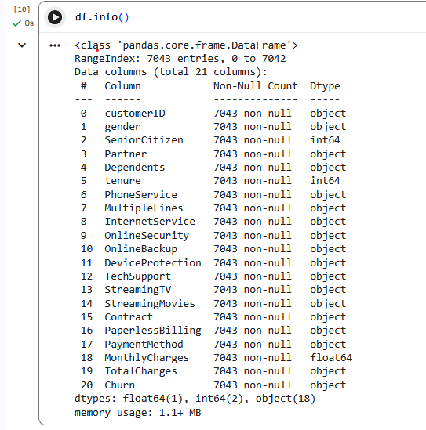 | The dataset consists of 7,043 entries with 21 columns.  It includes 18 categorical (object) variables, 2 integer variables, and 1 numerical (float) variable.  No missing values are detected, and the memory usage is approximately 1.1 MB.
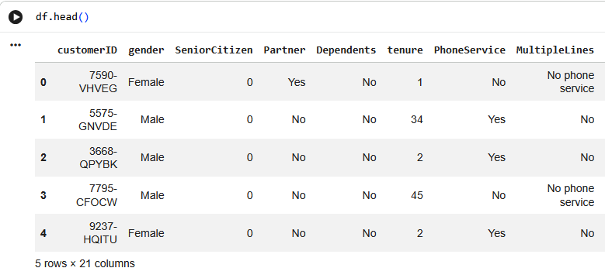 | This output displays the first five records of the dataset, providing an overview of customer attributes such as demographics, services subscribed, and billing information.
Table 1

Feature Description
The dataset is composed of both categorical and numerical features, reflecting different dimensions of customer profiles. As reported in the reference article, the majority of the variables are categorical, representing customer subscriptions, contract types, and service options, while a smaller number of features are numerical and relate to service duration and billing amounts.
Categorical features include variables such as gender, contract type, internet service, payment method, and various service-related options. Numerical features include tenure, monthly charges, and total charges. This combination of feature types requires appropriate preprocessing steps before model training, particularly encoding techniques for categorical variables and scaling for numerical variables.
The diversity of features enables the identification of behavioral patterns associated with churn and supports the application of both statistical and machine learning models.
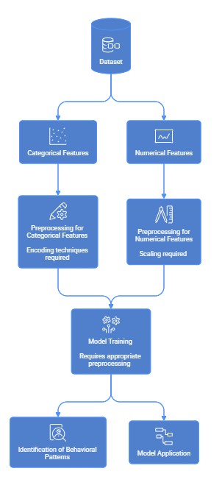
Dataset Feature Description and Preprocessing

Initial Data Exploration
An initial exploration of the dataset was conducted to assess the quality and distribution of data. The distribution of the target variable reveals that the dataset contains a higher proportion of non-churners compared to churners. This imbalance is common in churn datasets and must be carefully considered during model evaluation.
The dataset was also examined for missing values. Some attributes contain missing or invalid entries, which require appropriate handling during the data preparation phase. Ignoring missing values may negatively impact model performance and reliability.
Additionally, the presence of class imbalance was identified as a potential challenge. Since the number of non-churners significantly exceeds the number of churners, standard accuracy alone may not be a sufficient evaluation metric. Therefore, additional metrics such as recall and AUC are necessary to ensure meaningful performance assessment.
What to describe
- Percentage of churn vs non-churn
- Imbalance impact on learning
- Which columns have missing values

Exploratory Data Analysis (EDA)
Exploratory Data Analysis (EDA) was performed to better understand the relationship between customer attributes and churn behavior. The distribution of numerical variables such as tenure, monthly charges, and total charges was analyzed to observe differences between churners and non-churners. These variables provide important insights into usage patterns and customer lifetime.
In addition, categorical variables were examined with respect to churn to identify patterns related to service subscriptions and contract types. Visual analyses revealed that certain customer segments exhibit higher churn rates, particularly those with shorter contract durations or specific service combinations.
Key visualizations from the reference article were reproduced to ensure consistency and support the reproducibility objective of this study. These visualizations aid in identifying trends and validating the relevance of selected features for churn prediction.
What to describe
- Differences in distributions
- Which variables seem most discriminatory
- Similarity with the article’s plots

Insights from Data Understanding
The data understanding phase confirmed that the dataset is appropriate for customer churn prediction, containing a mix of categorical and numerical features with a binary churn target variable. Initial exploration revealed class imbalance and the presence of missing values, highlighting the need for careful preprocessing. Exploratory data analysis showed that variables such as tenure, monthly charges, and contract type are strongly associated with churn behavior. These insights form a solid foundation for the data preparation and modeling stages within the CRISP-DM framework.
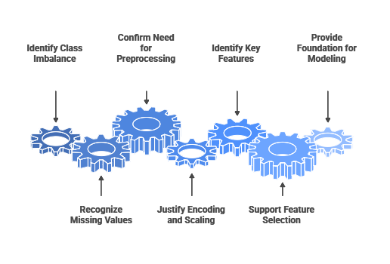
Data Understanding and Modeling Decisions

Chapter 4: Data Preparation
The data preparation stage in CRISP-DM is essential, as clean, well-structured data is key for building effective machine learning models.
This study prepares data by handling missing values, removing irrelevant features, encoding and scaling variables, selecting key features with GSA, and addressing class imbalance—mirroring the approach in the reference article to boost predictive performance and efficiency.

Data Preparation (CRISP-DM – Phase 3)

Data Cleaning
Data cleaning was performed to improve data quality and eliminate inconsistencies that could negatively impact model performance. The first step involved handling missing values present in specific attributes of the dataset. Missing or invalid entries were either removed or appropriately treated to ensure data completeness and consistency.
In addition, irrelevant or non-informative attributes, such as unique customer identifiers, were removed from the dataset. These attributes do not contribute to churn prediction and may introduce noise into the learning process. Removing such features helps reduce dimensionality and improves model efficiency, in line with the approach presented in the reference article.
Describe in report
- Which columns had missing values
- Why customerID was removed
- Impact on data quality

Data Transformation
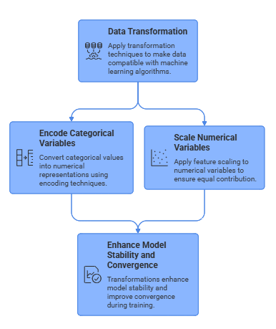
Data Transformation Process
Describe in report
- Why encoding is necessary
- Why scaling improves model performance

Feature Selection Strategy
Feature selection plays a crucial role in reducing dataset dimensionality and improving predictive performance. In this study, a two-stage feature selection strategy was adopted, consistent with the reference article. First, univariate feature selection techniques were used to filter out non-informative attributes based on their statistical relevance to the target variable.
In the second stage, the Gravitational Search Algorithm (GSA) was applied as an optimization-based feature selection method. GSA models each candidate solution as an agent and iteratively updates feature subsets based on gravitational attraction principles. The fitness function used in this process aims to minimize classification error, thereby selecting features that contribute most effectively to churn prediction.
Describe in report
- Purpose of univariate filtering
- Why GSA is used instead of simple filters
- Fitness function = error rate (as in article)

Handling Class Imbalance
Customer churn datasets are often characterized by class imbalance, where non-churners significantly outnumber churners. This imbalance can cause models to become biased toward the majority class, resulting in poor churn detection performance. To address this issue, resampling techniques were applied to balance the class distribution.
In line with the methodology described in the reference article, resampling strategies were used to improve model sensitivity to churners. Balancing the dataset improves recall and ensures that churn prediction models can effectively identify customers at risk of leaving.
Describe in report
- Imbalance problem
- Why recall and AUC are critical metrics
- Effect of resampling on class distribution

Final Prepared Dataset

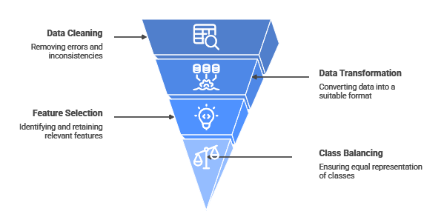
Data Preparation Process

The data preparation phase cleaned and structured the telecommunications dataset, tackling missing values, irrelevant features, and class imbalance. Advanced feature selection, including the Gravitational Search Algorithm, reduced complexity while keeping predictive accuracy.
This process ensured data quality, forming a reliable foundation for model training and scientific reproducibility within the CRISP-DM framework.

Chapter 5: Modeling
The modeling phase builds and evaluates predictive models to identify customer churn, following CRISP-DM guidelines. It includes algorithm selection, model training, and performance validation.
Various machine learning methods, including ensembles and boosting, were tested to find the best churn prediction model for telecommunications.

Modeling (CRISP-DM – Phase 4)

Reproduced Machine Learning Models

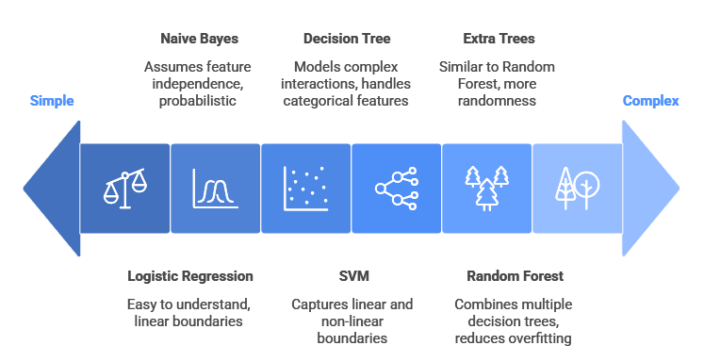
Machine learning models ranked by complexity and interpretability.
Explain in report
- All models are trained on the same dataset
- Purpose of testing multiple algorithms
- Baseline vs complex models

Ensemble and Boosting Techniques
In addition to classical machine learning models, ensemble and boosting techniques were employed to enhance predictive performance. Ensemble learning combines multiple weak or moderate learners to produce a stronger model, often resulting in improved accuracy and robustness.
AdaBoost was applied to iteratively adjust model weights by focusing on misclassified instances. XGBoost, a gradient boosting algorithm, was used due to its efficiency and strong performance in structured data problems. CatBoost was also implemented, as it is particularly well suited for datasets with categorical features. These techniques were included to reproduce the findings of the reference article, which identified AdaBoost and XGBoost as the best performing models in terms of accuracy and AUC
Explain in report
- Why ensemble models improve performance
- Relation to article’s results
- Boosting focus on hard-to-classify cases

Experimental Setup
A consistent experimental setup was used for all models to ensure reproducibility and fair comparison. The prepared dataset was split into training and testing sets using an 80% / 20% ratio, as described in the reference article. The training set was used for model learning and validation, while the test set was reserved for final performance evaluation.
To ensure reproducibility, random seeds were fixed for all experiments. This guarantees that model training and evaluation can be replicated and that results are not influenced by randomness in data splitting or algorithm initialization.
Explain in report
- Why 80/20 split was chosen
- Role of reproducibility
- Separation of training and evaluation

Cross-Validation k = 5 : ?
To further enhance model reliability and prevent overfitting, k-fold cross-validation was applied during the modeling phase. In this approach, the training data is divided into k subsets, and each model is trained and validated k times using different partitions of the data. In this study, a K-fold cross-validation strategy was adopted, consistent with the reference article.
Cross-validation was also used for hyperparameter tuning, allowing optimal model configurations to be selected based on average validation performance. This process improves generalization and ensures that the selected models perform consistently across different data samples rather than fitting specific training subsets.
Explain in report
- Why cross-validation is necessary
- Difference between training accuracy and CV accuracy
- Prevention of overfitting

The modeling phase applied several machine learning and boosting models to predict customer churn, allowing for a thorough performance comparison.
Using cross-validation and reproducible settings ensured reliable results and set the stage for evaluating models with multiple metrics against a reference article.

Chapter 6: Evaluation
The evaluation phase aims to assess the performance and effectiveness of the predictive models developed during the modeling phase. In accordance with the CRISP-DM methodology, this phase focuses on measuring model performance using appropriate evaluation metrics and comparing the obtained results with those reported in the reference article.
In this study, several quantitative metrics are used to evaluate classification performance, including confusion matrix-based measures and ROC-AUC analysis. The results obtained from different machine learning and ensemble models are analyzed, compared, and discussed to identify the most effective approaches for customer churn prediction.

Evaluation (CRISP-DM – Phase 5)

Evaluation Metrics
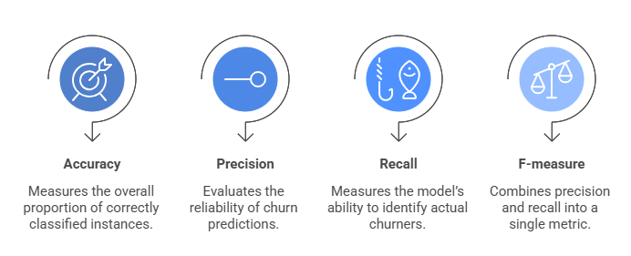
Churn Prediction Metrics
Explain in report
- Role of confusion matrix
- Why recall is critical for churn detection
- Meaning of each metric

AUC and ROC Curve Analysis
In addition to confusion matrix-based metrics, ROC curve analysis was used to evaluate model performance across different decision thresholds. The ROC curve plots the true positive rate against the false positive rate, providing a visual representation of a model’s discriminative ability.
The Area Under the Curve (AUC) was computed for all models as a global performance indicator. Higher AUC values indicate better separation between churners and non-churners. Consistent with the findings of the reference article, ensemble models generally achieved higher AUC scores compared to individual classifiers, highlighting the effectiveness of boosting techniques in churn prediction.
Explain in report
- Meaning of ROC curve
- Why AUC is threshold-independent
- Usefulness for imbalanced data

Reproduced Results
The evaluation results obtained from the implemented models were summarized using performance tables that include accuracy, precision, recall, F-measure, and AUC score. These tables allow direct comparison between different classifiers under identical experimental conditions.
The reproduced results are consistent with the trends reported in the reference article. Ensemble models such as AdaBoost and XGBoost achieved the highest performance in terms of accuracy and AUC, while classical models like Logistic Regression and Decision Trees provided competitive baseline performance. Minor variations in numerical values may be observed due to differences in implementation or random initialization, but overall model rankings remain consistent with the original study.
Explain in report
- How reproduced results compare with article
- Similar performance ranking
- Acceptable deviations

Discussion on Results
The evaluation results indicate that ensemble and boosting techniques outperform traditional machine learning models in customer churn prediction. Models such as AdaBoost and XGBoost demonstrated superior performance across multiple metrics, particularly in terms of accuracy and AUC, confirming the conclusions of the reference article.
The effectiveness of ensemble learning can be attributed to its ability to combine multiple classifiers and focus on difficult-to-classify instances. Classical models like Logistic Regression and Decision Trees remain valuable due to their interpretability and relatively strong baseline performance.
Observed deviations between reproduced results and those reported in the article are minor and can be explained by differences in data preprocessing, random seed initialization, or library implementations. Overall, the evaluation phase confirms the robustness of the original findings and validates the reproducibility of the proposed churn prediction methodology.

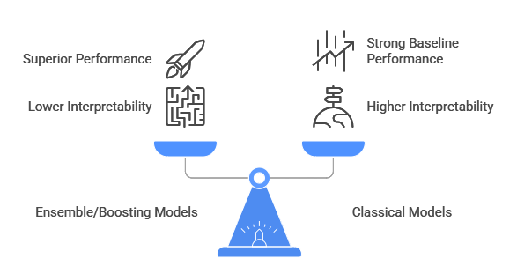
Balancing Performance and Interpretability in Churn Prediction

The evaluation phase provided a comprehensive assessment of churn prediction models using multiple quantitative metrics. By combining confusion matrix-based measures with ROC-AUC analysis, this phase enabled a balanced and reliable comparison of model performance.
The results confirm that ensemble and boosting models achieve superior predictive performance, particularly in identifying customers at risk of churn. These findings are consistent with the reference article and support the use of advanced machine learning techniques in churn prediction systems. This evaluation phase completes the analytical assessment and prepares the groundwork for discussing potential improvements and deployment considerations.

7. Proposed Improvements and Extensions
7.1 Clustering for Customer Segmentation
- Motivation
- Clustering algorithms (K-Means / Hierarchical)
- Insights gained
7.2 Explainable AI (XAI)
- Importance of interpretability
- Feature importance analysis
- SHAP or LIME explanations
7.3 Comparative Analysis
- Original vs enhanced approach

8. Deployment Perspective (CRISP-DM – Phase 6)
8.1 Potential Business Deployment
- Integration into telecom decision systems
8.2 Limitations of the Study
- Dataset limitations
- Model assumptions
8.3 Ethical and Responsible AI Considerations

9. Conclusion and Future Work
9.1 Summary of Reproducibility Findings
9.2 Key Lessons Learned
9.3 Future Research Directions

References
- Lalwani et al. (2021)
- Additional academic sources

Appendices
Appendix A: Notebooks Description
Appendix B: Hyperparameters
Appendix C: Additional Figures and Tables

